Project Description
This is a statement of work agreed between Telekinesys Research Ltd, t/a Havok (Havok) and Forum Energy Technologies Inc (FET) about work to be performed for the integration of Havok Physics into FETs products.
FET provide remotely operated vehicle (ROV) training simulations and a C++ API that is physics engine agnostic. The product is called VMAX. It is targeted to the industry dealing with subsea simulation. FET provides their own 3ds Max-style scene editor which allows physics setup. It uses Lua scripting with physics API call bindings.

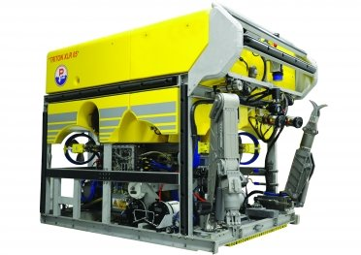
Remotely operated vehicle (ROV)

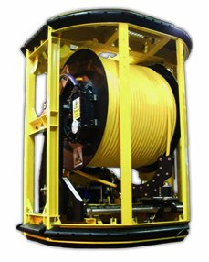
Tether management system (TMS)
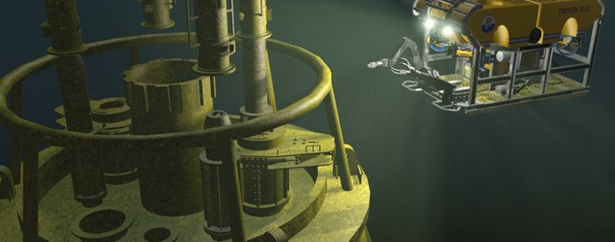

VMAX Simulator

System Specification
The simulation is targeted to run on a dedicated physics server running a 32 or 64 Bit Windows operating system. The FET simulation equipment uses a rack with a 3.2 GHz quad-core blade dedicated to physics. The physics simulation is supposed to make efficient use of all blade resources and the blade will be equipped with sufficient memory, so memory limiting techniques are not necessary.

Simulation Specification
The simulation will use the Havok Physics product to simulate rigid bodies, constraints between them and cables.
A full simulation scenario setup consists of:
- Heavy mass (25-50 tons) object suspended from 3000 meter cable under water.
- TMS suspended from 2250 meter cable under water.
- ROV tethered by 833 segment neutrally buoyant cable to TMS.
- ROV drives over to cable and attaches manipulator arm.
- ROV and cables react to ocean currents.
- Simulation frequency: 60 Hertz

Required Development
For achieving the targeted simulation, the following features need to be implemented in the Havok Physics SDK.
- The models produced for the simulation consist in general of objects with sub-shapes. Feedback of data and forces must be accessible at sub-shape level. In a Havok Physics world, the objects map to rigid-bodies and a sub-shape to a single convex vertices shape or a collection thereof. The Havok Physics SDK provides a callback mechanism to get notified of events on rigid-bodies. For FET, this callback mechanism must be extended to allow registering a callback on sub-shape level.
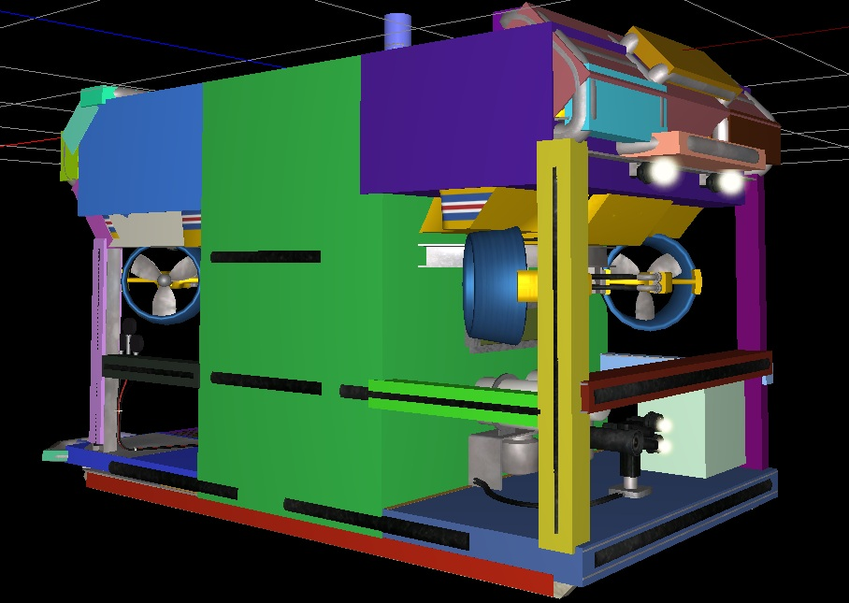
- FETs toolkit offers retrieval methods for force and torque on objects down to sub-shape level as well as on cables down to segment level. The Havok Physics simulation calculates this data internally but does not expose it at interface level. For FET, an utility class must be written to retrieve the data. On objects, this will be directly possible at rigid body granularity. On sub-shapes, an accumulator will collect the data on demand. On cables, a (possibly scaled) measure of stress end-to-end of the cable can be retrieved. It will not provide internal stress, strain or torque on individual cable segments.
- A typical simulation scenario involves still or powered objects suspended on long steel cables. Also, powered objects tethered to anchors using neutrally buoyant cables must be simulated. The constraint toolkit of Havok Physics contains chain constraints which offer a basis for developing the required functionality. A special type of chain constraint needs to be built, which reacts to participating media (external non-collision forces) to account for ocean currents, buoyancy and similar. It will employ a hierarchical scheme to solve for the chain segments by adapting to the local curvature of the cable. This will counter performance issues with the scheduling of the chain constraint in a highly connected simulation.
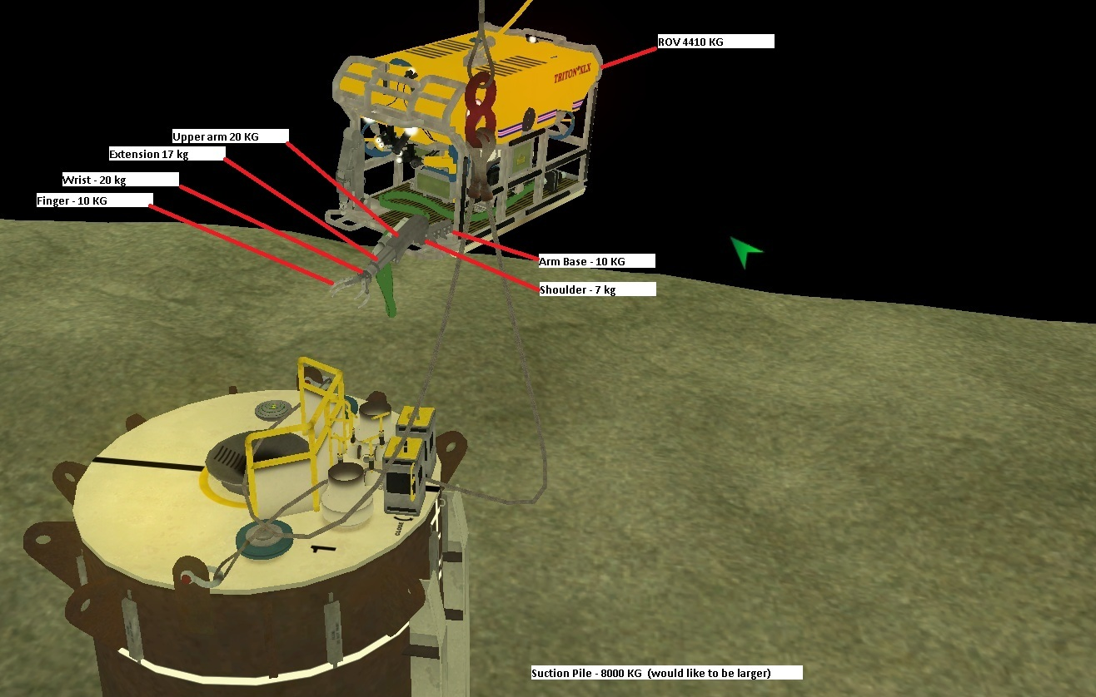
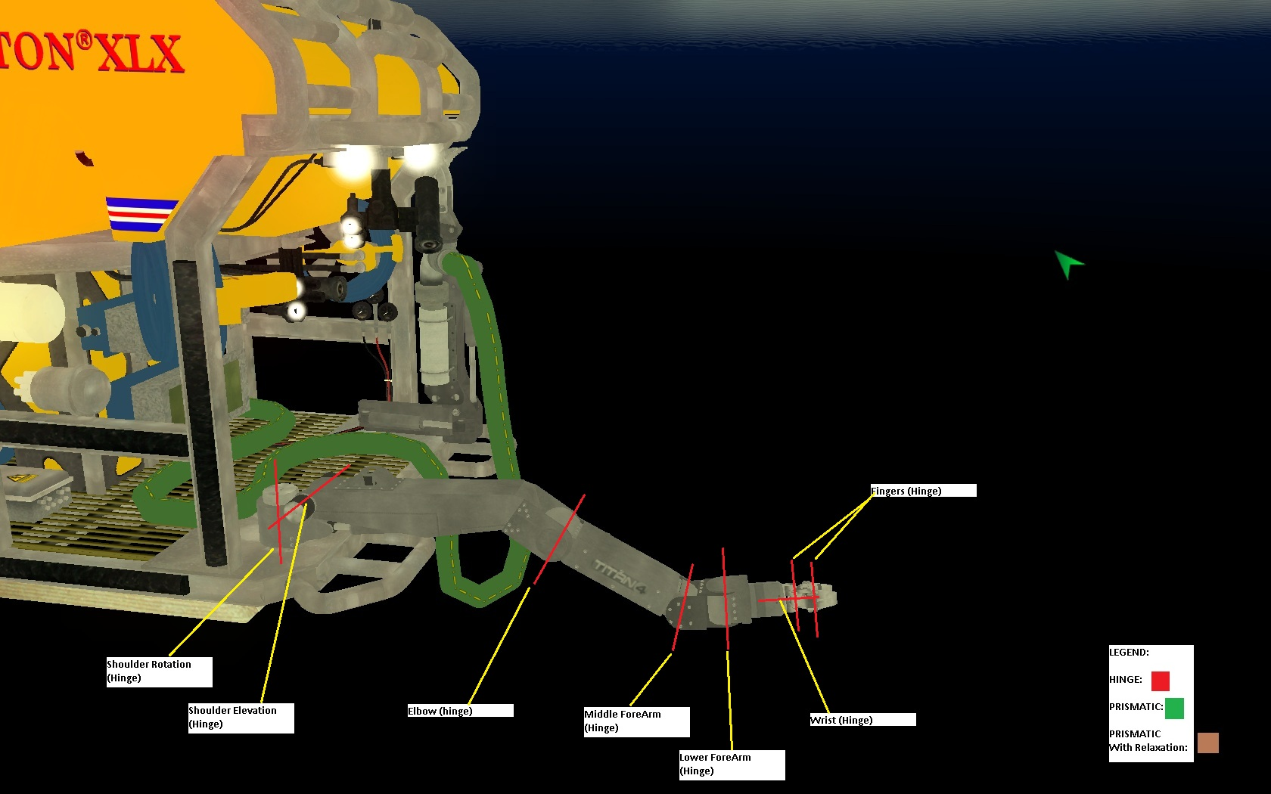
- Some manipulators used in the simulation have rather small scale mechanics or are made out of non-rigid material. FET accounts for that by allowing to specify for each constraint a measure of allowed deviation from the ideal constrained movement. The Havok Physics constraints are assembled out of constraint atoms. A new atom needs to be developed which implements the desired functionality.

Development Milestones
In order to implement the required software pieces, the following milestones can be identified:
Milestone | Implementing Development Requirement | Time required | Task
A | 1 | 2 weeks | Implementation of a callback filter with state and registry. Multiple shape keys per sub-shape mapping. Assigning materials to sub-shapes (including friction and restitution). Code visibility: level 3. Integration into Havok demo code. Exclusivity possible.
B | 2 | 1 week | Implementation of an utility class providing sub-shape to Havok shape key mapping, appropriate rigid body query methods and accumulators / integrators for derived quantities of compound Havok shapes. Code visibility: level 3. Integration into Havok demo code. Exclusivity possible.
C | 3 | 6 weeks | Implementation of a new chain constraint with hierarchical solving of virtual chain segments. Upgrade of the constraint scheduler to include the new constraint in the chain priority queue using the current virtual chain rank. Code visibility: level 1 and 2. Integration into Havok Physics SDK and documentation.
D | 3 | 4 weeks | Addition of participating media support specific to the new chain constraint. Code visibility: level 2. Integration into Havok Physics SDK and documentation.
E | 4 | 2 weeks | Implementation of a constraint relaxation atom. Using the atom, a ball-socket, a hinge and a prismatic constraint get implemented. Code visibility: level 2. Integration into Havok Physics SDK and documentation.

Possible parallelism, provided engineering resources are available:
- A, C and E are independent
- B depends on all
- D depends on C

Internal Notes
Milestone A:
This will be an extended version of the BreakOffUtil. Bodies will need to register with it. They get examined for their shape keys and a map is built. TBD how to hand in the material list. Possibly also a registry and matching by name (Destruction approach). The util is accompanied by a callback filter and an action for actually providing the friction and restitution. Must be multithreading safe, therefore lock the register/unregister.
Milestone B:
This is a straight forward util. For memory efficiency check whether reusing the shape key mapping of Milestone A is possible. Chains will need to traverse all segment bodies and collect for all substeps of the timestep. Therefore make force retrieval on chains async and delayed after worldstep. If state is needed use rigid body properties.
Milestone C:
Build Jacobian stabilization according to Rheinmetall chain. The chain gets setup as usual, but the segments get solved virtually: for every sufficiently straight pair of segments, schedule the next step Jacobian setup to only simulate a body of twice the size and interpolate result to both. Recurse this. Refinement of virtual bodies by thresholding on bending strength of ragdoll constraints as an actual angle is not present. Probably will need support of the Jacobian setup for this (level 1 code). Export the current number of segments to parameterize the chain-length driven constraint scheduler modification done for the Rheinmetall chains. This will auto-adjust the constraint solving priority.
Milestone D:
Provide an interface for setting external forces per timestep on the new chain constraint. Fixed number of forces, maybe even a specific buoyancy which rotates gravity. Write a new atom to evaluate that and inject into the substep solver. Make sure the force can lead to chain refinement in the same timestep. As this chain will need to cope with low frequency solving, may need to apply the inertia modification tech idea to the external impulses to avoid high frequency jitter.
Milestone E:
Model relaxation using the stabilization atom. Just clip the stabi impulse to zero inside the desired relaxation measure. Build new ball-socket, hinge and prismatic constraint with it, in order not to confuse with usage of stabilization. No need to have this backwards compatible to existing constraints.

SOW produced 02.08.2012 by Peter Kipfer

